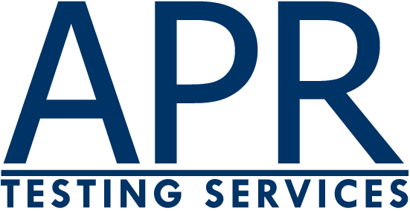

APR Testing Services
Scarsdale, NY 10583
Tel.: 617.244.7405 request@APRTestingServices.com

Order Form
Learning Business Procedures Test (LBPT)

Billing Address* Shipping (if different)
Name
Company
Title
Address
City
State
Zip
Phone
Email
*If paying by credit card, enter the address to which the card statement is sent.

Description | Unit Price | Quantity | Total
Ten Candidate Pack (including web scoring) | $440
Overnight Shipping | $29
International Shipping | $70
New York firms add 8.375% sales tax
 |  | Total
Preferred date of arrival: __________________________

14 Day Money Back Guarantee

Payment Method
(Check form of payment)
Check |  |  | Check #
Purchase Order |  |  | PO#
Visa/Mastercard |  |  | Name on Card
American Express |  |  | Credit Card #
Discover |  |  | Expiration Date |  | CSC
Email, Mail or Fax Order to:
APR Testing Services
62 Candlewood Road; Scarsdale, NY 10583
617.244.7405 (voice)
617.244.8904 (fax)
request@APRTestingServices.com (email)

